

Program: MATHEMATICS METHODS 3 & 4
2022

Note: This outline and assessment dates are subject to change!

The program you have been issued references all objectives in the Curriculum Council syllabus.
The syllabus may be easily downloaded from the Curriculum Council website www.scsa.wa.edu.au

SYLLABUS CONTENT

Structure of the syllabus

The Year 12 syllabus is divided into two units which are delivered as a pair. The notional time for the pair of units is 110 class contact hours.

Unit 3

Unit description

The study of calculus continues with the derivatives of exponential and trigonometric functions and their applications, together with some differentiation techniques and applications to optimisation problems and graph sketching. It concludes with integration, both as a process that reverses differentiation and as a way of calculating areas. The fundamental theorem of calculus as a link between differentiation and integration is emphasised. In statistics, discrete random variables are introduced, together with their uses in modelling random processes involving chance and variation. This supports the development of a framework for statistical inference.
Access to technology to support the computational aspects of these topics is assumed.

Learning outcomes

By the end of this unit, students:
- understand the concepts and techniques in calculus, probability and statistics
- solve problems in calculus, probability and statistics
- apply reasoning skills in calculus, probability and statistics
- interpret and evaluate mathematical and statistical information and ascertain the reasonableness of solutions to problems.
- communicate their arguments and strategies when solving problems.

Unit 4

Unit description
The calculus in this unit deals with derivatives of logarithmic functions. In probability and statistics, continuous random variables and their applications are introduced and the normal distribution is used in a variety of contexts. The study of statistical inference in this unit is the culmination of earlier work on probability and random variables. Statistical inference is one of the most important parts of statistics, in which the goal is to estimate an unknown parameter associated with a population using a sample of data drawn from that population. In the Mathematics Methods ATAR course, statistical inference is restricted to estimating proportions in two-outcome populations.
Access to technology to support the computational aspects of these topics is assumed.

Learning outcomes

By the end of this unit, students:
- understand the concepts and techniques in calculus, probability and statistics
- solve problems in calculus, probability and statistics
- apply reasoning skills in calculus, probability and statistics
- interpret and evaluate mathematical and statistical information and ascertain the reasonableness of solutions to problems.
- communicate their arguments and strategies when solving problems.
General Capabilities which will be incorporated into the program
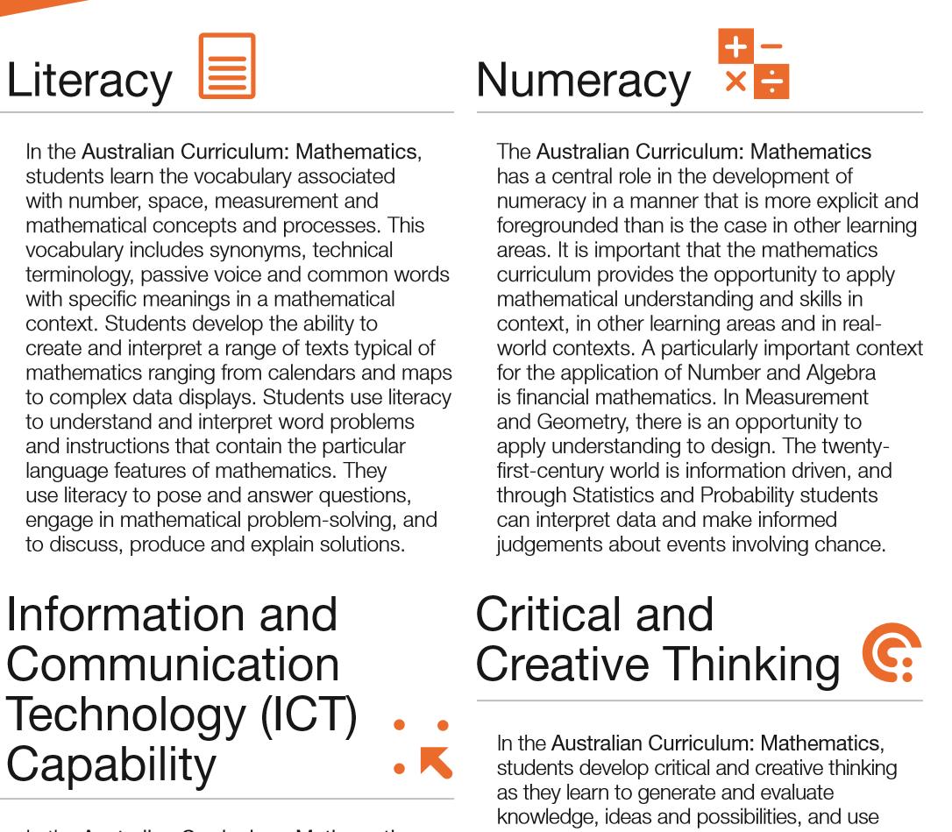  Literacy |   Numeracy |   Critical and Creative thinking |   ICT | 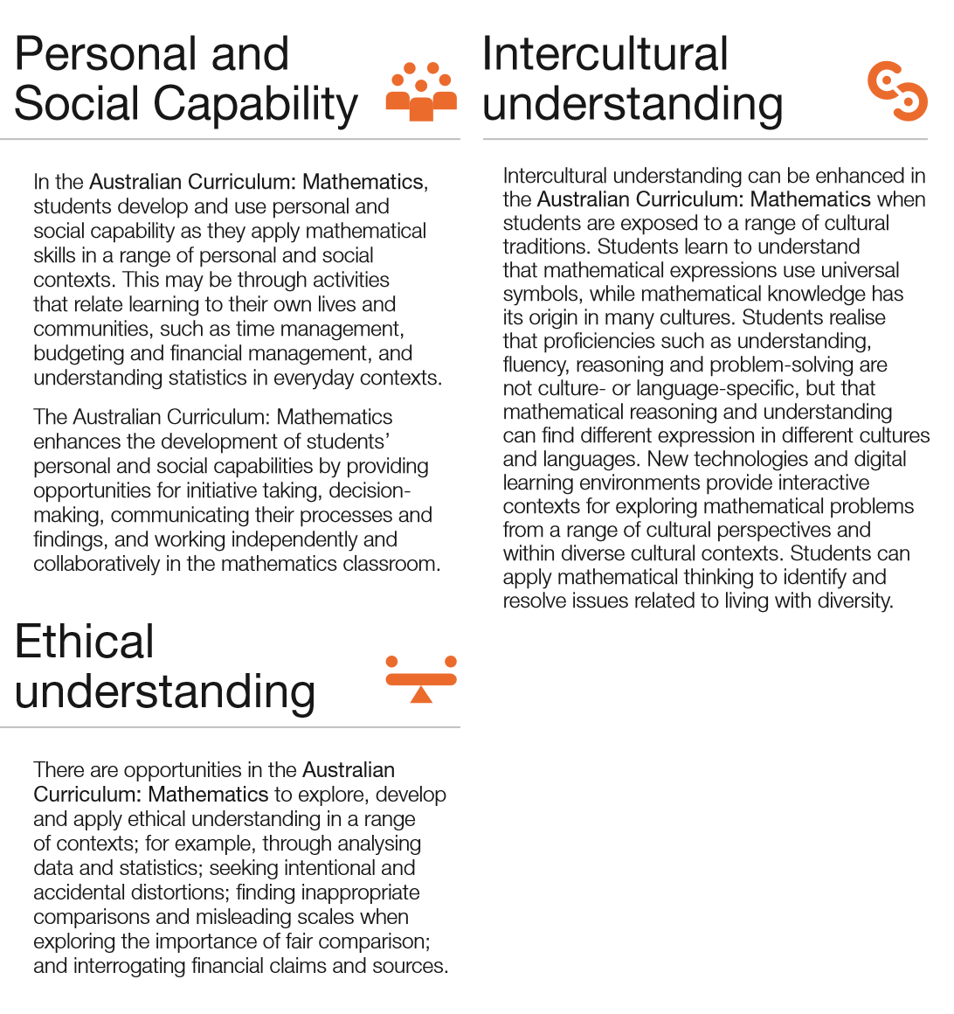  Social Capability |   Intercultural understanding |   Ethical Understanding
The general capabilities encompass the knowledge, skills, behaviours and dispositions that will assist students to live and work successfully in the twenty-first century. Teachers may find opportunities to incorporate the capabilities into the teaching and learning program for the Mathematics Methods ATAR course. The general capabilities are not assessed unless they are identified within the specified unit content.
Habits of Mind
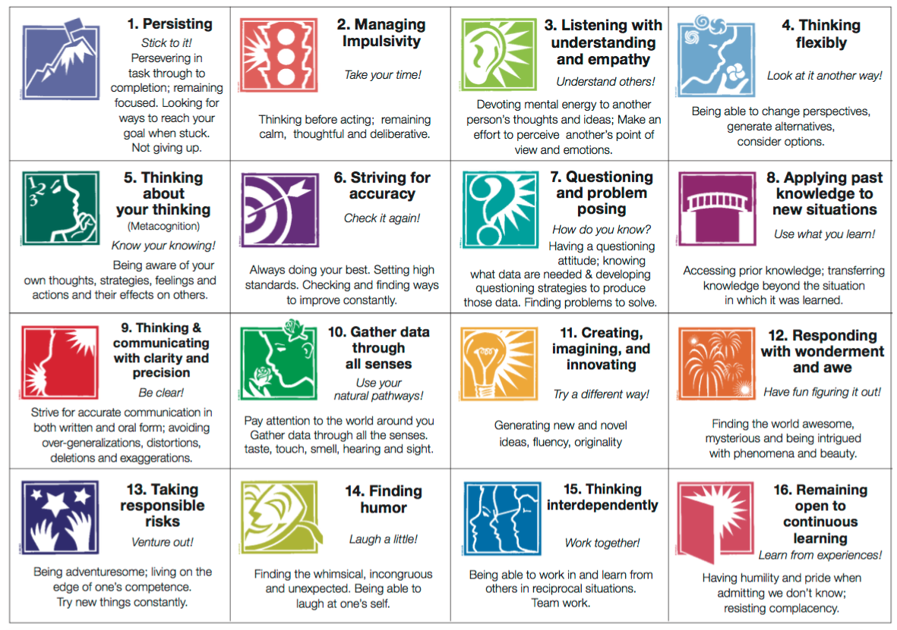  Persisting |   Manage Impulsivity |   Understanding and empathy |   Thinking flexibly |   Think about thinking |   Strive for Accuracy |   Posing Questions |   Apply past knowledge
  Clarity and precision |   Use all senses |   Imagining and Creating |   Wonderment and awe |   Responsible risk taking |   Find humour |   Think interdependently |   Continuous learning

Course Outline
TEXT Mathematics Methods 3 & 4 by A.J. Sadler
WEBSITE www.scsa.wa.edu.au/

Week | Content | Text
Term 4 2021  Weeks  5-6 | Exam Review  Topic 3.1: Further differentiation and applications (20 hours)  Differentiation rules  3.1.7 examine and use the product and quotient rules  3.1.8 examine the notion of composition of functions and use the chain rule for determining the derivatives of composite functions | Sadler Chapter 1
Weeks  7-8 | The second derivative and applications of differentiation  3.1.10 use the increments formula: $δy≈\frac{dy}{dx}×δx$ to estimate the change in the dependent variable $y$ resulting from changes in the independent variable $x$  3.1.11 apply the concept of the second derivative as the rate of change of the first derivative function  3.1.12 identify acceleration as the second derivative of position with respect to time  3.1.13 examine the concepts of concavity and points of inflection and their relationship with the second derivative  3.1.14 apply the second derivative test for determining local maxima and minima  3.1.15 sketch the graph of a function using first and second derivatives to locate stationary points and points of inflection  3.1.16 solve optimisation problems from a wide variety of fields using first and second derivative | Sadler Chapter 2
Term 1 2022  Week 1-3  Week 4-5  (School Ball and Swimming Carnival)  Week 6  Week 7  Week 8  Week 9 | Topic 3.2: Integrals (20 hours)  Anti-differentiation  3.2.1 identify anti-differentiation as the reverse of differentiation  3.2.2 use the notation $\int{f\left(x\right)dx}$ for anti-derivatives or indefinite integrals  3.2.3 establish and use the formula:$x^{n}dx=\frac{1}{n+1}x^{n+1}+c$ for $n≠-1$  3.2.6 identify and use linearity of anti-differentiation  3.2.7 determine indefinite integrals of the form $\int{f\left(ax-b\right)dx}$  3.2.8 identify families of curves with the same derivative function  3.2.9 determine $f\left(x\right),$ given $f'\left(x\right)$ and an initial condition $f\left(a\right)=b$  Definite integrals and First Fundamental Theorem  3.2.10 examine the area problem and use sums of the form $\sum_{i}{f\left(x_{i}\right) δx_{i}}$ to estimate the area under the curve $y=f(x)$  3.2.11 identify the definite integral $\int_{a}^{b}{f\left(x\right)dx }$as a limit of sums of the form $\sum_{i}{f\left(x_{i}\right) δx_{i}}$  3.2.12 interpret the definite integral $\int_{a}^{b}{f\left(x\right)dx }$as area under the curve $y=f\left(x\right)$ if $f\left(x\right)>0$  3.2.13 interpret $\int_{a}^{b}{f\left(x\right)dx }$as a sum of signed areas  3.2.14 apply the additivity and linearity of definite integrals  Applications of integration  3.2.18 calculate total change by integrating instantaneous or marginal rate of change  3.2.19 calculate the area under a curve  3.2.20 calculate the area between curves  3.2.21 determine displacement given velocity in linear motion problems  3.2.22 determine positions given linear acceleration and initial values of position and velocity.  Fundamental theorem of Calculus  3.2.15 examine the concept of the signed area function $F\left(x\right)=\int_{a}^{x}{f\left(t\right)dt}$  3.2.16 apply the theorem: $F^{'}\left(x\right)=\frac{d}{dx}\left(\int_{a}^{x}{f\left(t\right)dt}\right)=f\left(x\right)$, and illustrate its proof geometrically  3.2.17 develop the formula $\int_{a}^{b}{f'\left(x\right)dx=f\left(b\right)-f(a)}$ and use it to calculate definite integrals  Exponential functions  - estimate the limit of $\frac{a^{h}-1}{h}$ as $h→0$, using technology, for various values of $a >0$  - identify that $e$ is the unique number $a$ for which the above limit is 1  - establish and use the formula $\frac{d}{dx}\left(e^{x}\right)=e^{x}$  - use exponential functions of the form $Ae^{kx}$ and their derivatives to solve practical problems  3.1.9 apply the product, quotient and chain rule to differentiate functions such as $xe^{x}$, $\tan{x,} \frac{1}{x^{n}}$ , $x\sin{x,} e^{-{x}}\sin{x}$ and $f\left(ax-b\right)$  3.2.4 establish and use the formula $\int{e^{x}dx=e^{x}+c}$  Trigonometric functions  3.2.5 establish and use the formula:$\int{\sin{x dx=-\cos{x+c}}}$ and  $\int{\cos{x dx= -\sin{x+c}}}$  - establish the formulas $\frac{d}{dx}\left(\sin{x}\right)=\cos{x }$ and $\frac{d}{dx}\left(\cos{x}\right)=-\sin{x}$ by graphical treatment, numerical estimations of the limits, and informal proofs based on geometric constructions  - use trigonometric functions and their derivatives to solve practical problems  - apply the product, quotient and chain rule to differentiate functions such as $xe^{x}$, $\tan{x,} \frac{1}{x^{n}}$ , $x\sin{x,} e^{-{x}}\sin{x}$ and $f\left(ax-b\right)$ | Chapter 3  TEST 1  Week 2  Fri 10%  SS: Goal setting  Chapter 3  21CLD:  Knowledge Construction  ICT for learning  Approximating Areas under the Curve  INV 1  Wed Week 5  Fri 10%  Chapter 4  Chapter 5  Chapter 6  Chapter 7  TEST 2  Week 9  Mon 10%
Week 10 | Topic 3.3: Discrete random variables (15 hours)  General discrete random variables  3.3.1 develop the concepts of a discrete random variable and its associated probability function, and their use in modelling data  3.3.2 use relative frequencies obtained from data to obtain point estimates of probabilities associated with a discrete random variable  3.3.3 identify uniform discrete random variables and use them to model random phenomena with equally likely outcomes  3.3.4 examine simple examples of non-uniform discrete random variables  3.3.5 identify the mean or expected value of a discrete random variable as a measurement of center, and evaluate it in simple cases  3.3.6 identify the variance and standard deviation of a discrete random variable as measures of spread, and evaluate them using technology  3.3.7 examine the effects of linear changes of scale and origin on the mean and the standard deviation  3.3.8 use discrete random variables and associated probabilities to solve practical  problems.  End of Term 1 | Chapter 8

Term 2  Week 1-2 | Bernoulli distributions  3.3.9 use a Bernoulli random variable as a model for two-outcome situations  3.3.10 identify contexts suitable for modelling by Bernoulli random variables  3.3.11 determine the mean $p$ and variance $p\left(1-p\right)$of the Bernoulli distribution with parameter $p$  3.3.12 use Bernoulli random variables and associated probabilities to model data and solve practical problems  Binomial distributions  3.3.13 examine the concept of Bernoulli trials and the concept of a binomial random variable as the number of ‘successes’ in $n$ independent Bernoulli trials, with the same probability of success $p$ in each trial  3.3.14 identify contexts suitable for modelling by binomial random variables  3.3.15 determine and use the probabilities $P\left(X=x\right)=\left(\begin{matrix}n \\ x\end{matrix}\right)p^{x}{\left(1-p\right)}^{n-x}$ associated with the binomial distribution with parameters $n$ and $p$; note the mean $np$ and variance $np\left(1-p\right)$ of a binomial distribution  3.3.16 use binomial distributions and associated probabilities to solve practical problems | Chapter 9
Week 3 | Revision & Exam Preparation | SS: Self-Regulation and Time Management

Week 4-5  Semester 1  Exams | FIND OUT ALL YOU CAN ABOUT THE FORMAT OF THE EXAM:  Time allowed, number of questions, marks and average time spent per question.  Do past WACE. papers to be familiar with the format and standard.  BE PREPARED:  Revise, revise, revise! Means PRACTICE, PRACTICE, PRACTICE,  Bring pens, pencil, drawing instruments, tables books, calculator (check calculator works!), spare batteries, your brain (ditto!).  Eat and sleep well, be early, be confident, be a little nervous.  USE THE READING TIME TO PLAN YOUR EXAM:  Read all instructions carefully.  Skim through all questions to see the work that is ahead of you.  Note the difficult questions which will require more time; plan your time! What order will you do the questions in?  SPEND THE FIRST MINUTE OF EACH QUESTION PLANNING AND THINKING:  You don’t need to be writing all of the time. (What you’re writing may be wrong and a waste of time!)  Read each question carefully and decide what needs to be found.  Make sure you use all the information given.  PACE YOURSELF; KEEP AN EYE ON THE TIME:  Work steadily; make sure you are not spending too much time on one question.  Don’t rush or you’ll make silly mistakes, and your work will be messy.  Don’t panic if you run out of time; it is better to get most questions right than to get all questions wrong.  Complete the work you do know, rather than rushing.  WRITE CLEARLY, DRAW BIG DIAGRAMS:  Show working; spread out your work neatly, use as much paper as you like.  Demonstrate to the marker that you know your Maths.  Write down the page, not across; use words and diagrams if appropriate.  Don’t use liquid paper; draw a line through mistakes; use pencil only for diagrams.  MAKE SURE YOU HAVE ANSWERED THE QUESTION:  Does it sound reasonable? Correct units included? Correct number of decimal places?  Highlight the final answer in a box. Should you write it in a sentence?  Feel confident about yourself when you have answered a question correctly.  ATTEMPT EVERY QUESTION:  Aim to earn some marks for every question, even if it requires an educated guess.  Try to finish each question before moving on, so that you don’t have to worry about coming back to it.  If a question is too hard, skip it and leave time to come back to it later.  MOVE ON IF YOU’RE GETTING NOWHERE:  If your working-out of a hard question is taking too long, then it’s probably wrong!  If you’re stuck, don’t waste valuable time getting bogged down. Stop, retrace your steps, think about a simpler method, or start again. Sometimes it’s even better to skip the question and return to it with a fresh mind.  AT THE END OF THE EXAM:  Check your work, and go back | Semester One  Exam 18%
Week 6-7  Week 8 | Semester One Exam Review  Topic 4.1: The logarithmic function (18 hours)  Logarithmic functions  4.1.1 define logarithms as indices: $a^{x}=b$ is equivalent to $x=\log_{a}{b}$ i.e. $a^{\log_{a}{b}}=b$  4.1.2 establish and use the algebraic properties of logarithms  4.1.3 examine the inverse relationship between logarithms and exponentials: $y=a^{x}$ is equivalent to $x=\log_{a}{y}$  4.1.4 interpret and use logarithmic scales  4.1.5 solve equations involving indices using logarithms  4.1.6 identify the qualitative features of the graph of $y=\log_{a}{x}$ ($a>1)$, including asymptotes, and of its translations $y=\log_{a}{x}+b$ and ${y=log}_{a}{(x-c)}$  4.1.7 solve simple equations involving logarithmic functions algebraically and graphically  4.1.8 identify contexts suitable for modelling by logarithmic functions and use them to solve practical problems  - define the natural logarithm $\ln{x}=\log_{e}{x}$  - examine and use the inverse relationship of the functions $y=e^{x}$ and $y=\ln{x}$  4.1.11 establish and use the formula $\frac{d}{dx}\left(\ln{x}\right)=\frac{1}{x}$  4.1.12 establish and use the formula $\int{\frac{1}{x}dx=\ln{ x }+c}$, for $x>0$  4.1.13 determine derivatives of the form $\frac{d}{dx}\left(\ln{f(x})\right)$ and integrals of the form $\int{\frac{f^{'}\left(x\right)}{f\left(x\right)}}dx$, for $f (x)>0$  4.1.14 use logarithmic functions and their derivatives to solve practical problems | Chapter 1  Chapter 2  INV 2  Week 8  Fri 10%
Weeks 9-10 | Topic 4.2: Continuous random variables and the normal distribution (15 hours)  General continuous random variables  4.2.1 use relative frequencies and histograms obtained from data to estimate probabilities associated with a continuous random variable  4.2.2 examine the concepts of a probability density function, cumulative distribution function, and probabilities associated with a continuous random variable given by integrals; examine simple types of continuous random variables and use them in appropriate contexts  4.2.3 identify the expected value, variance and standard deviation of a continuous random variable and evaluate them using technology  4.2.4 examine the effects of linear changes of scale and origin on the mean and the standard deviation  End of Term 2 | Chapter 3

Term 3  Week 1  Week 2  Week 3  Week 4-5  Week 6-8  Week 9-10  Term 4  Week 1-2 | Normal distributions  4.2.5 identify contexts, such as naturally occurring variation, that are suitable for modelling by normal random variables  4.2.6 identify features of the graph of the probability density function of the normal distribution with mean μ and standard deviation σ and the use of the standard normal distribution  4.2.7 calculate probabilities and quantiles associated with a given normal distribution using technology, and use these to solve practical problems  Topic 4.3: Interval estimates for proportions (22 hours)  Random sampling  4.3.1 examine the concept of a random sample  4.3.2 discuss sources of bias in samples, and procedures to ensure randomness  4.3.3 use graphical displays of simulated data to investigate the variability of random samples from various types of distributions, including uniform, normal and Bernoulli  Sample proportions  4.3.4 examine the concept of the sample proportion $\hat{p}$ as a random variable whose value varies between samples, and the formulas for the mean $p$ and standard deviation $\sqrt{\frac{p\left(1-p\right)}{n}}$ of the sample proportion $\hat{p}$  - examine the approximate normality of the distribution of $\hat{p}$ for large samples  - simulate repeated random sampling, for a variety of values of $p$ and a range of sample sizes, to illustrate the distribution of $\hat{p}$and the approximate standard normality of $\frac{\hat{p} –p}{\sqrt{\frac{\hat{p}\left(1-\hat{p}\right)}{n}}}$ where the closeness of the approximation depends on both $n$ and $p$  Confidence intervals for proportions  4.3.7 examine the concept of an interval estimate for a parameter associated with a random variable  4.3.8 use the approximate confidence interval $\left(\hat{p}-z\sqrt{\left(\frac{\hat{p}\left(1-\hat{p}\right)}{n}\right)}, \hat{p}+z\sqrt{\left(\frac{\hat{p}\left(1-\hat{p}\right)}{n}\right)}\right)$ as an interval estimate for $p$, where $z$ is the appropriate quantile for the standard normal distribution  4.3.9 define the approximate margin of error $E=z\sqrt{\frac{\hat{p}\left(1-\hat{p}\right)}{n}}$ and understand the trade-off between margin of error and level of confidence.  4.3.10 use simulation to illustrate variations in confidence intervals between samples and to show that most, but not all, confidence intervals contain $p$  Exam Preparation  Semester Two Exam  End of Term 3  Semester Two Exam Review  Master Class | Chapter 4  21CLD:  Collaboration and Skillful Communication  Identifying examples of Real World Applications of Distribution Types  Chapter 5  Chapter 6  TEST 3  Week 3  Mon 10%  Chapter 6  Test 4  Week 6  Fri  10%  Semester Two Exam  22%

– Grade descriptions Year 12
A | Identifies and organises relevant information  Identifies and organises relevant information from previous parts of a problem and brings them together to solve subsequent problems.  Defines variables and equations from text and diagrams.  Organises data in a concise, clear format and appropriately presents it in tabular, diagrammatic and/or graphical form.  Identifies the underlying assumptions related to the relevant mathematics of an investigation.
Chooses effective models and methods and carries through the methods correctly
Selects an appropriate strategy and applies mathematical knowledge to solve non-routine problems.
Generalises and extends models from previous parts of the question.
Translates between representations in unpractised ways.
Selects appropriate calculator techniques to solve multi-step problems in unfamiliar contexts.
Selects and appropriately uses numerical, graphical, symbolic and statistical methods to develop mathematical ideas.
Produces results, carries out analysis and generalises in situations requiring investigative techniques.
Follows mathematical conventions and attends to accuracy
Follows mathematical conventions and attends to accuracy in non-routine situations.
Completes concise and accurate solutions to mathematical problems set in applied and theoretical contexts.
Selects, extends and applies mathematical and/or statistical procedures to investigate a problem.
Links mathematical results to data and contexts to reach reasonable conclusions
Recognises implied conditions in extended responses and defines and explains the limitations of models.
Interprets the result and draws the correct conclusion about the effect of changing conditions.
Considers the strengths and limitations of an investigation and refines the results to make sensible conclusions.
Communicates mathematical reasoning, results and conclusions
Sets out the steps of the solution in a clear and logical sequence, including suitable justification and explanation of methods and processes used.
Adds a detailed diagram to illustrate and use in the solution of a problem.
Presents work with the final answer clearly identified, using the correct units and relating to the context of the question.
Communicates investigation findings with a comprehensive interpretation of mathematical results in the context of the investigation.

B | Identifies and organises relevant information  Identifies and organises relevant information for problems involving a few steps or processes.  Draws a diagram and labels it with appropriate variables.  Organises data clearly and appropriately presents it in tabular, diagrammatic and/or graphical form.  Identifies suitable variables and constant parameters related to various aspects of an investigation.
Chooses effective models and methods and carries through the methods correctly
Selects an appropriate strategy and applies mathematical knowledge to solve simple non-routine problems.
Translates between representations in practised ways.
Selects appropriate calculator techniques to solve multi-step problems.
Selects and appropriately uses numerical, graphical, symbolic and statistical methods to develop mathematical ideas.
Attempts to analyse and calculate specific cases of generalisation in situations requiring investigative techniques.
Follows mathematical conventions and attends to accuracy
Interprets and uses mathematical terminology, symbols and conventions in routine situations.
Rounds, unprompted, to suit context or correctly to specified accuracy.
Completes mostly accurate solutions to mathematical problems set in applied and theoretical contexts.
Selects and applies mathematical and/or statistical procedures previously learnt to investigate a problem.
Links mathematical results to data and contexts to reach reasonable conclusions
Identifies specified conditions, recognises and rejects inappropriate solutions.
Links the effect of changing conditions to the original solution.
Uses examples in mathematical analysis of an investigation and draws valid conclusions related to a given context.
Communicates mathematical reasoning, results and conclusions
Carries through calculations and simplifications in a clear sequence, showing a logical line of reasoning.
Defines variables associated with a given diagram and uses them in the working of a problem.
Presents work with the final answer clearly identified and using the correct units.
Communicates investigation findings in a systematic and concise way using mathematical language and relating the solution to the original problem or statement.

C | Identifies and organises relevant information  Identifies and extracts key information needed to solve a familiar problem.  Identifies variables in a given diagram.  Organises some data and presents it in tabular, diagrammatic and/or graphical form.  Identifies the key mathematical content related to various aspects of an investigation in a given context.
Chooses effective models and methods and carries through the methods correctly
Selects from a range of strategies and formulae and applies mathematical knowledge in practised ways to solve routine problems.
Recognises and uses information in different representations.
Uses familiar calculator applications to solve routine problems.
Selects appropriate numerical, graphical, symbolic and statistical methods to carry through a single thread of reasoning in situations requiring investigative techniques.
Follows mathematical conventions and attends to accuracy
Applies mathematical definitions, rules and procedures in practised situations.
Applies basic conventions for diagrams and graphs.
Rounds appropriately in a given context and to specified accuracy in short responses.
Generates some accurate and generally complete solutions to mathematical problems set in applied and theoretical contexts.
Selects and applies, with direction, mathematical and/or statistical procedures previously learnt to investigate a problem.
Links mathematical results to data and contexts to reach reasonable conclusions
Identifies specified conditions and recognises inappropriate solutions in routine problems.
Recognises that changing conditions will affect the outcome.
Makes inferences from analysis and uses these to draw conclusions related to a given context for investigation.
Communicates mathematical reasoning, results and conclusions
Shows adequate working and supports answers with simple or routine statements.
Relates the working to a labelled diagram that has been given as part of the question.
Presents work with the final answer, but not always clearly identified.
Communicates investigation findings in a systematic way using some mathematical expression and everyday language.

D | Identifies and organises relevant information  Uses given information to solve some simple routine problems.  Identifies variables in a simple diagram.  Displays data using an inappropriate presentation format.  Identifies some mathematical content of an investigation.
Chooses effective models and methods and carries through the methods correctly
Follows an appropriate strategy to solve simple routine and familiar problems that require short responses.
Deals with information in familiar representations only.
Uses a calculator for straightforward problems.
Makes some attempt to select appropriate numerical, graphical, symbolic and statistical methods in situations requiring investigative techniques.
Follows mathematical conventions and attends to accuracy
Applies limited mathematical conventions to practised problems.
Rounds inconsistently or inappropriately.
Generates partly accurate and generally incomplete solutions to mathematical problems set in applied and theoretical contexts.
Attempts to apply, with direction, mathematical and/or statistical procedures previously learnt to investigate a problem.
Links mathematical results to data and contexts to reach reasonable conclusions
Is unable to recognise specified or changing conditions in routine problems.
Draws some conclusions from the results of an investigation.
Communicates mathematical reasoning, results and conclusions
Shows some working in an attempt to answer simple questions.
Sets out calculations in a manner that is difficult to check for accuracy.
Presents working with no clear indication of the final answer evident.
Offers simple conclusions that are not supported by data or calculations.

E | Does not meet the requirements of a D grade and/or has completed insufficient assessment tasks to be assigned a higher grade.

